Muhammad Umar Farooq: Writing Task 1
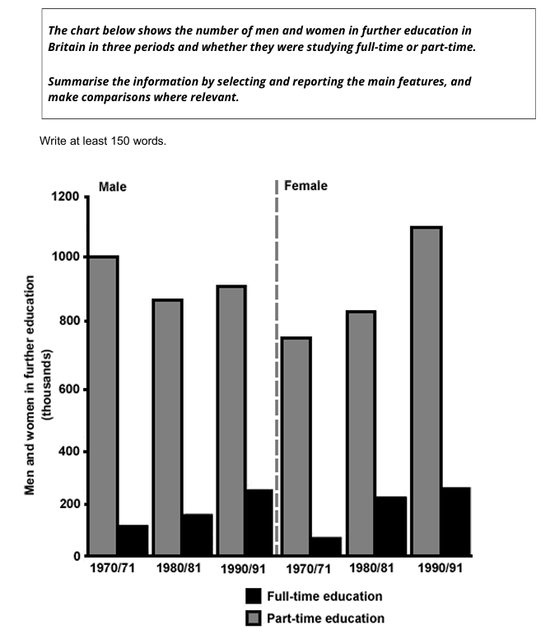
The chart illustrates the participation of men and women in higher education in Britain in three different time frames: 1970/1971, 1980/1981 and 1990/1991.

Overall, Britain had the more part-time students across three different time period, both men and women. This trend fluctuated for men, but for women, there was an increasing trend.

Looking at the details, in 1970 and 1971 the number of men in regular enrollment education was roughly 160, while the number of part-time learners was close to 1000. For women full-time studies expressed near 130, while non-full-time scholar rose to about 770, in comparison, fewer women were in academia than men.
However, in 1980 and 1981, men and women were same in education collectively. Part time men numbered 880, while women in this category were approximately 860. On the other hand, full-time Scholars in men category on 180, and women at 220 according to an estimate.
Lastly, in 1990 and 1991, women tended to have more influence in learning and made significant gains.
Part-time education for males were about 860, while for females 1100. Moreover, full-time student in male category were at 250, and in the women category, they were at 260 over the period.

